vivek_narayanan@yahoo.com

Hi venkat

i m sending entire process in this mail..

By the I m using PC having

Windows XP Professional –2002, Service pack 1, 2.19 GHz & 512 MB RAM.

Here I m going to make simple form based on SCOTT.EMP table.

1—I started forms builder

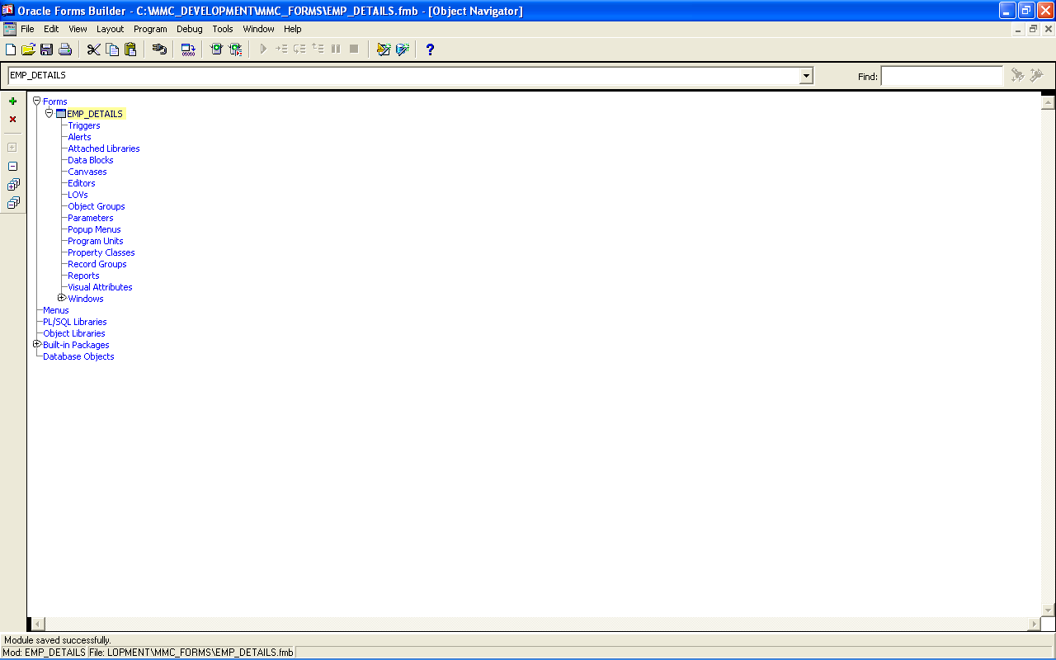

2—I started OC4J container from Forms developer menu.

Details of Which u can see as…..

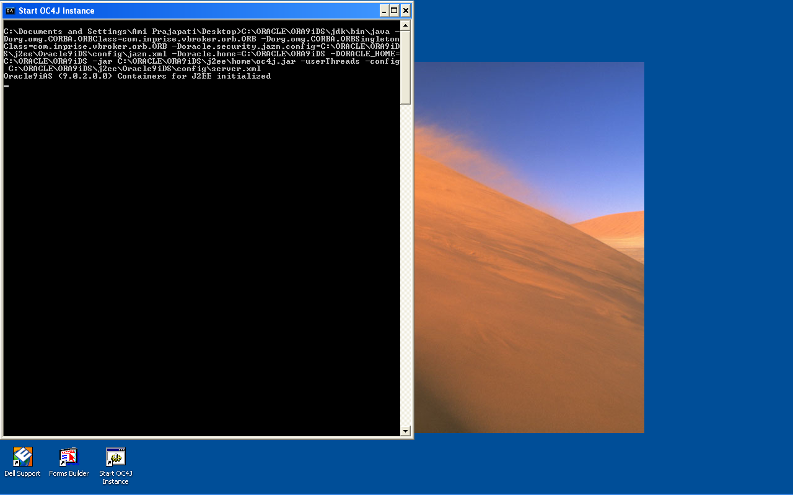

3— From Form builder I made connection with Oracle 9i Database.

Userid:scott/tiger@santram

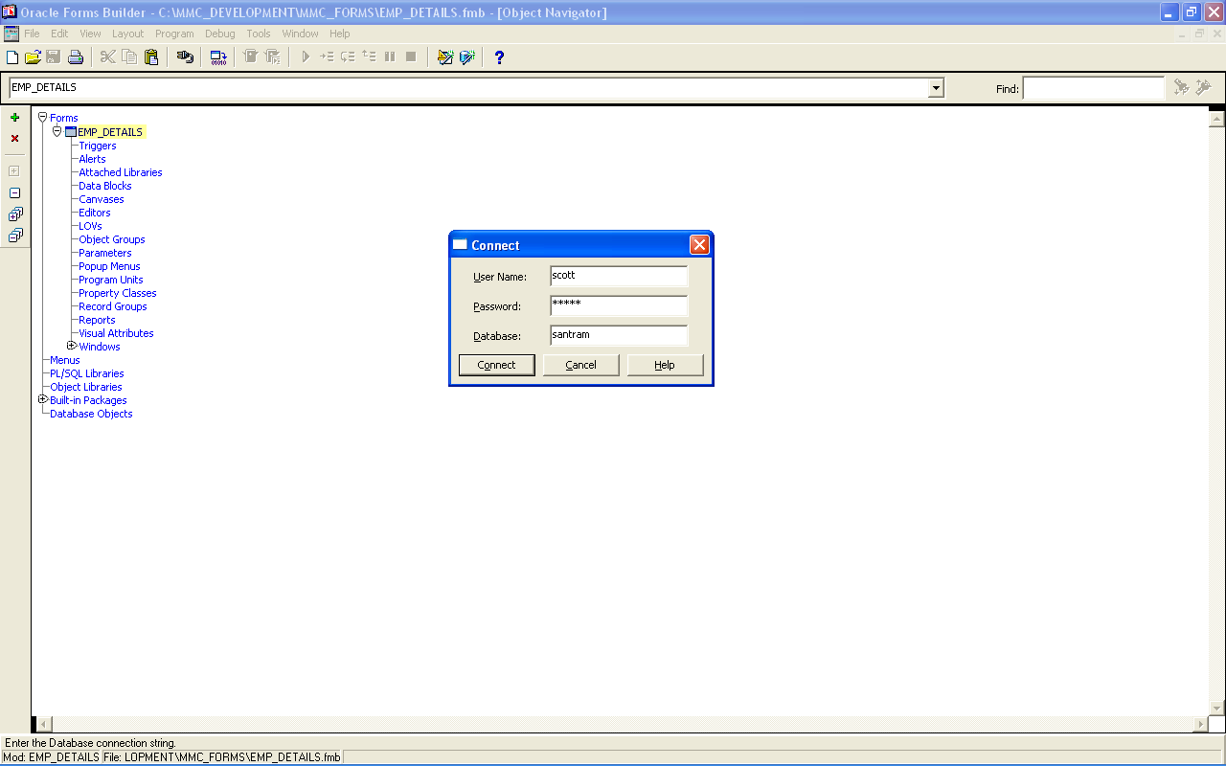

If I try to connect with Database before start up of OC4J Instance…It gives me error of

“ No http listener available ”…so I I have to connect Database after start up of OC4J Instance.

4—Now I open new form which interacts with EMP table.lets call this form as EMP_details.fmb

5— In this form..i run Datablock wizard & Layout wizard.

After this it is something like this….

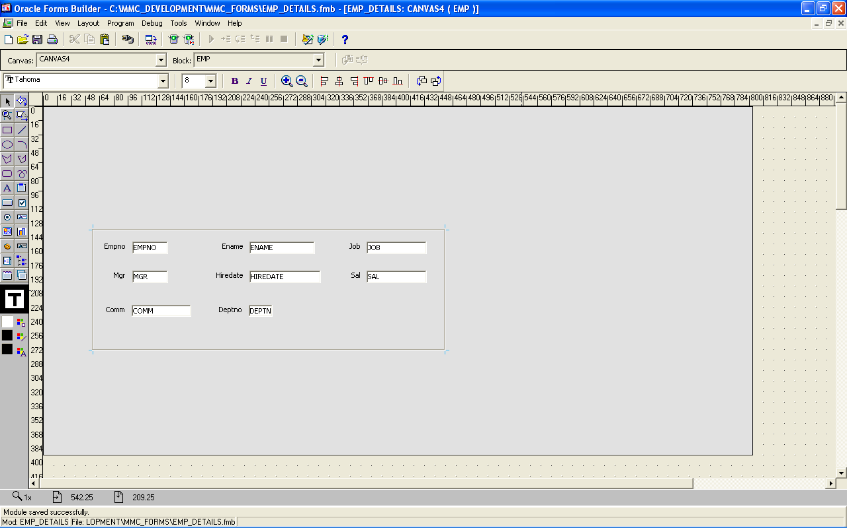

6—Now I press CTRL+R to run the form…

so form opens in Internet explorer as…

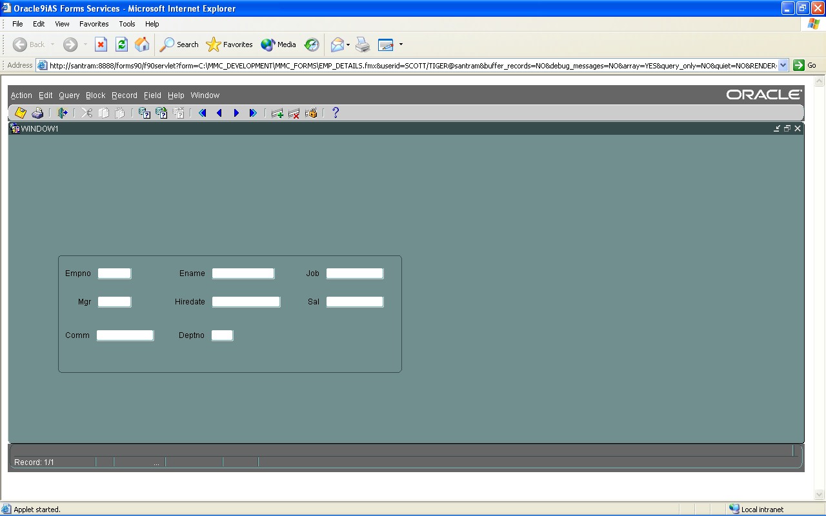

Meanwhile this form opening happens….in background…screen of OC4J Instance changes something like this

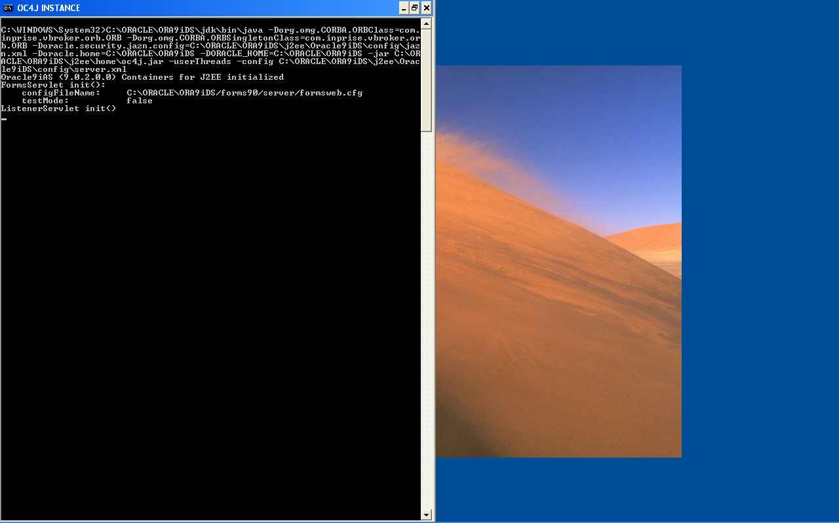

you can see difference between figure of step—2 & this one.

so now if I close the Internet explorer & againg try to run form by CTRL+R then it gives me error like…

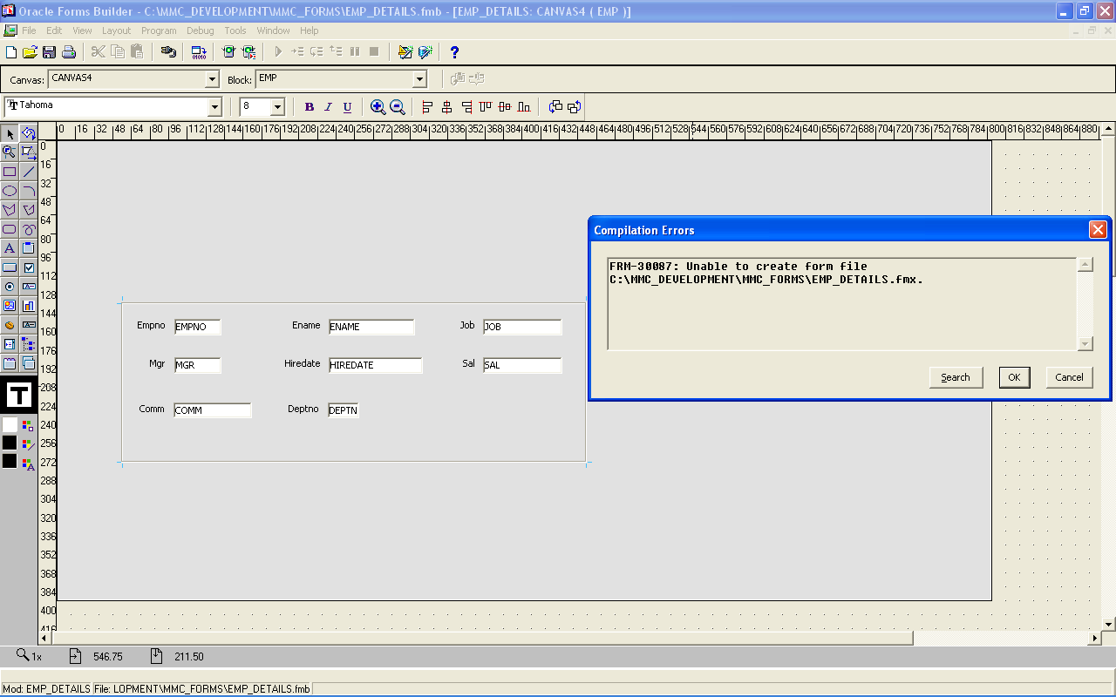

So I have to close OC4J instance by “ Shutdown OC4J instance” which is available in menu of forms builder, & then again restart it.

Only after restarting OC4J instance …I can run the form again…

So as many time as I do chages in form & want to see effect in browser…that many times I have to shutdown OC4J instance & again restart it.

I think now you got complete idea of this.

Q-1—What should I do in order to overcome problem of OC4J Instance.

Q-2— Here Emp.Empno has Number datatype..so if we write some character in this textbox
Then form runtime automatically show message that “ only numeric entries are allowed “

But in case…Emp.Ename has datatype of character.so if I put some number in this textbox & try to save it..then it gets saved…so how could I prevent numeric entries in textbox which accept only charcter.What code I should write….

