Oracle Forms Property Pallette for Data Block item:

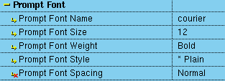

What is the meaning of “*” next to Plain

What is the meaning of little red X to the left of “Prompt Font Spacing” ?

